Version overview

Date | Version | Author | Comment
12/20/22 | V3 | Lacatus Arpad Alex & Marcu Horea Radu | Third version(beta)

System requirements for PostMe

1 Introduction 2
2 General view of actors and use cases 2
3 Detailed description of actors and use cases 2
3.1 Actors 2
3.1.1 Administrator 2
3.1.2 Customer 3
Type: ……….. 3
3.1.3 Provider 3
3.2 Use cases 3
3.2.1 Use Case Diagram for Actor1 3
3.2.2 Use Case Diagram for Actor2 3
3.2.3 Use Case Diagram for Actor3 4
3.2.4 Use Case Diagram for Actor_{n} 4
4 Glossary – used terms 5

Introduction

The project presented in this document is a social app that provides a virtual space for its users suited for posting everything they have in mind, ask any questions, provide support for other users, create new topic of discussion, post any content they would like to share and earn coins through contributing in our community.
As this is a group project, all the tasks will be separated between the two members. Horea has done the main page, forum page the login and signup pop-ups while Alex has done the post page, the database and the connection to the server which handles the requests. For the diagrams, each of the members have done 6, so that there are 12 diagrams in total. Also at the documentation and presentation we have worked together.

General view of actors and use cases
This chapter should give a brief description of the actors interacting with the system (the types of external users, user groups and external entities). I t also should describe the use cases present in the system.

Actor | Type | Description
Moderator | Human | The person administrating a specific forum.
User | Human | The regular person using this website mainly for entertainment.
Administrator | Human | The person who administrates the web-site.
System | System | The system handles every computer based operation.

Detailed description of actors and use cases

Actors
This chapter should give a detailed description of the actors interacting with the system.
Example for e-commerce:

Moderator

Type: human
Detailed description:
This actor is the person administrating the system. The administrator is the one responsible for maintenance of a specific forum. He is the one who keeps in check the users, handles reports, punishes misbehavior, gives rewards, sets the topic of the forum.

Where is used:
This actor is used in the: “Moderator page” use case
. “Moderator Log-in “use case.
“Creating a new forum” use case
“Modifying a post info from the forum” use case
“Warns misbehaved users” use case
“Handling reports” use case
“Rewards users” use case

User

Type: human
Detailed description:
This actor is the regular person who accesses the site. The user is the most common type of actor for this site, being able to see all the different forums, post, like, comment and spend their virtual currency.
Where is used:
This actor is used in the: “User page” use case.
“User log-in” use case.
“Join a forum” use case.
“Post in a forum” use case.
“Edit his profile” use case.
“Report other users” use case.
“Interact with posts” use case.

Administrator
Type: human
Detailed description:
This actor is the one who can control the site. This user is the developer, being the most unique one, having access to almost everything in the site.
Where is used:
This actor is used in the: “Administrator page” use case.
“Receive requests from users/moderators” use case.
“Updates the web-site” use case.
“Provides maintenance in case of bugs” use case.

System
Type: system
Detailed description:
This actor is the only one which is not a human. This is the representation of the system which updates all the necessary fields in the databse.
Where is used:
This actor is used in the: “System page” use case.
“Updates the comment sections” use case.
“Updates the database” use case.
“Handles log-ins” use case.
“Updates the like/dislike counters” use case.

Use cases
This sub-chapter should describe how each actor would interact with the system. If the actor is a human, then describe typical ways he will use the system. System requirements captured in this way are called use cases.

Use Case Diagram for Moderator
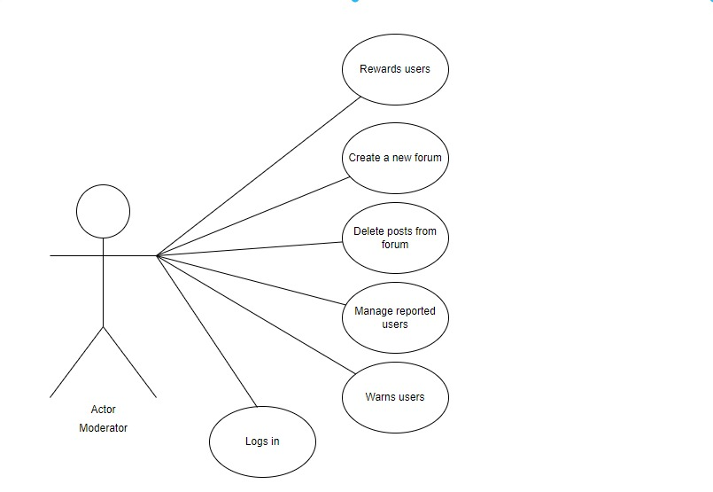

Use Case Diagram for User
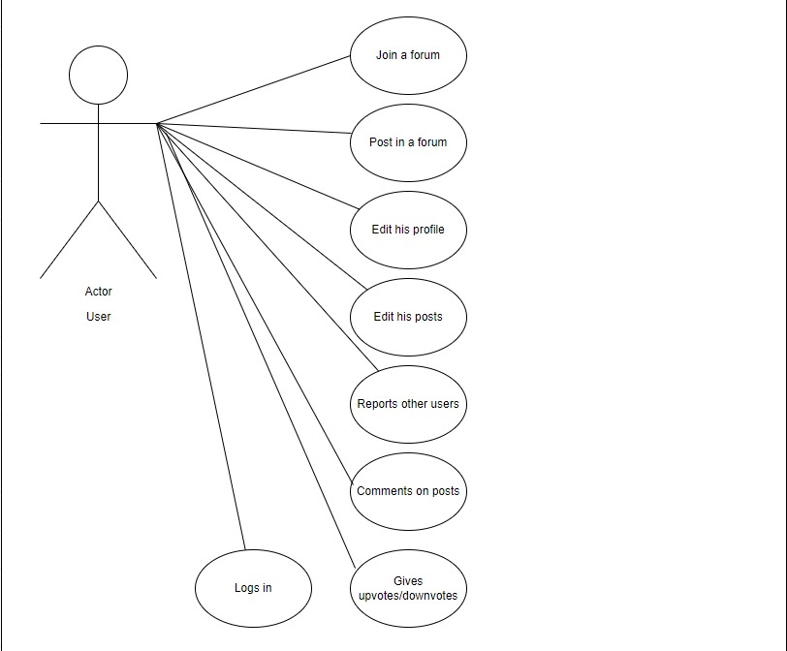

Use Case Diagram for Administrator
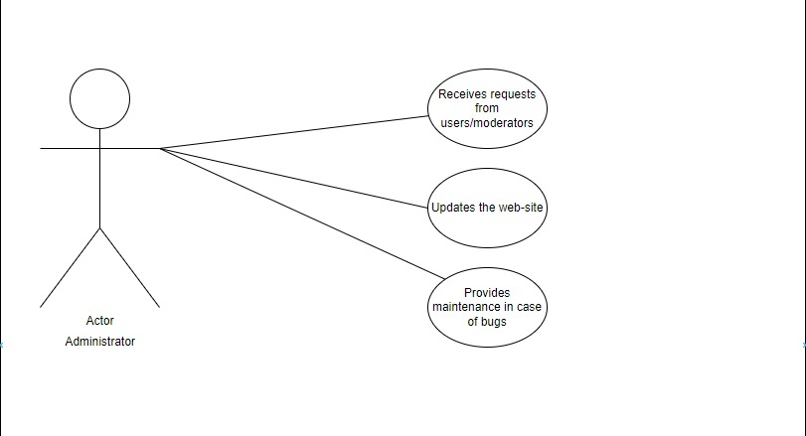

Use Case Diagram for System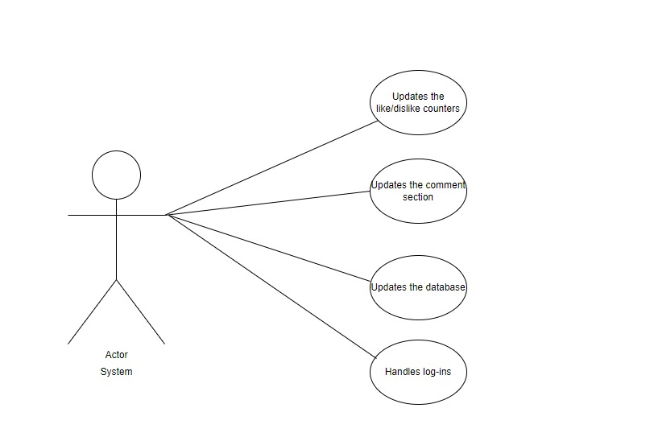

Glossary – used terms
This chapter should contain all the key items or terms or entities the application deals with.
Here is an example were the glossary terms are defined:

Term | Use cases | Description
Administrator account  authentication | Administrator Log-in use case | Contains all the information needed by the administrator that wants to authenticate itself in the system using a user password schema
Provider account authentication | Provider Log-in use case | Contains all the information needed by a Provider that wants to authenticate itself in the system using a ticket schema
Maintenance file | Administrator page case | Contains all the information used by the system.
Order file | Order page | Latest orders.
…………….. | …………… | ………………………………………………………….
………………. | ………… | ………………………………………………………….

Terms with related meanings and/or that are used in similar contexts can be grouped by term groups as depicted in the following table.

Term Groups | Included terms and term groups | Description
Authentication | Administrator password authentication, Provider password authentication | Defines a general group of credentials used in the authentication process

